DESIGN TABLES FOR PRODUCT AND CATEGORY ENTITIES.
Project Title: E-Commerce Order Management Database System

Project Title : E-Commerce Order Management Database System
Student Name : Yakesh J
Register Number : C4S38024
Department : Bsc
Course : Artificial intelligence (AI)
Academic Year : 2026 – 2027

1. Create Database
CREATE DATABASE EcommerceDB;
USE EcommerceDB;

2. Create Category Table
CREATE TABLE Category (
category_id INT PRIMARY KEY AUTO_INCREMENT,
category_name VARCHAR(100) NOT NULL
);

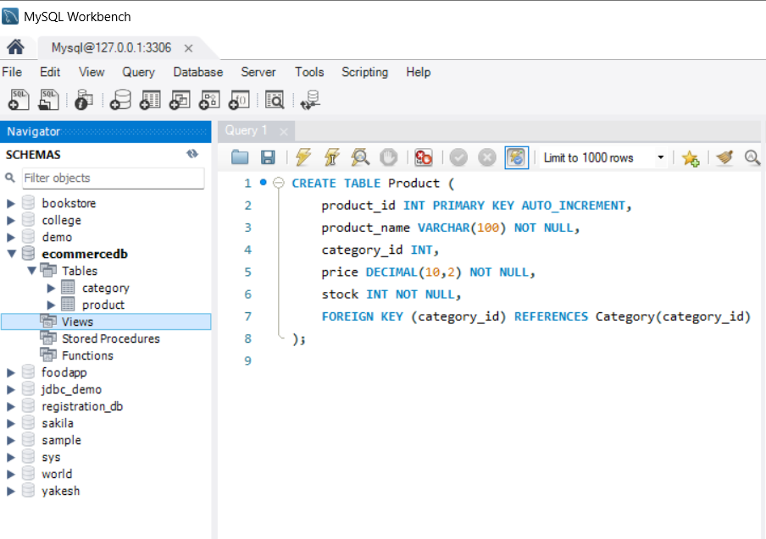

3. Create Product Table
CREATE TABLE Product (
product_id INT PRIMARY KEY AUTO_INCREMENT,
product_name VARCHAR(100) NOT NULL,
category_id INT,
price DECIMAL(10,2) NOT NULL,
stock INT NOT NULL,
FOREIGN KEY (category_id) REFERENCES Category(category_id)
);

4. Insert Data into Category
INSERT INTO Category (category_name)
VALUES
('Electronics'),
('Clothing'),
('Books'),
('Home Appliances');

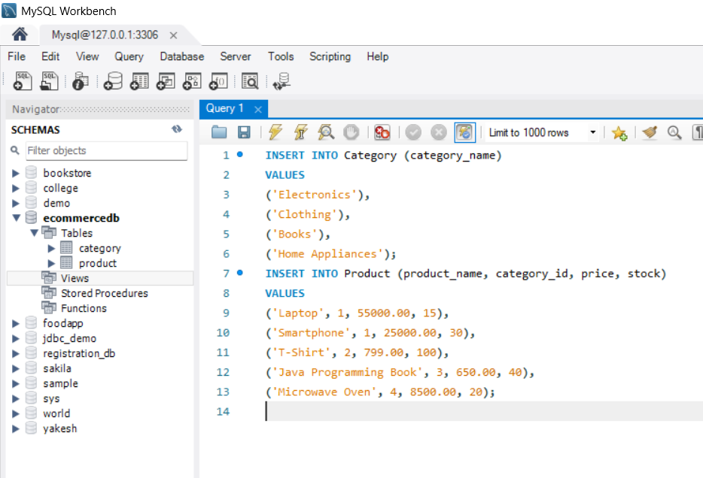
5. Insert Data into Product
INSERT INTO Product (product_name, category_id, price, stock)
VALUES
('Laptop', 1, 55000.00, 15),
('Smartphone', 1, 25000.00, 30),
('T-Shirt', 2, 799.00, 100),
('Java Programming Book', 3, 650.00, 40),
('Microwave Oven', 4, 8500.00, 20);

6. Display Products
SELECT * FROM Product;

7. Update Product Details
Example: Update Laptop price and stock.
UPDATE Product
SET price = 53000.00,
stock = 20
WHERE product_id = 1;

8. Delete a Product
Example: Delete T-Shirt.
DELETE FROM Product
WHERE product_id = 3;

9. Category-wise Product Report
SELECT
c.category_name,
p.product_name,
p.price,
p.stock
FROM Category c
JOIN Product p
ON c.category_id = p.category_id
ORDER BY c.category_name;

10. Count Products in Each Category
SELECT
c.category_name,
COUNT(p.product_id) AS Total_Products
FROM Category c
LEFT JOIN Product p
ON c.category_id = p.category_id
GROUP BY c.category_name;

